Non-rechargeable alkaline batteries charger

*Ilias-Man*

https://easy-electronics4u.blogspot.com/

We thought that limiting the current of recharging the batteries did the trick, but no! The electrolyte leaks from the end of the negative terminal. When the battery leaks, it loses in the best case 50% of its capacity. More leakage always ends with a small explosion, so another method is needed!!!

The technique of a discontinuous contact: thanks to this technique the battery could suffer much less stress when recharging but on condition of leaving the battery two times longer to rest than to recharge (2 seconds of 6) 2 seconds charging, 4 seconds resting. And it works! Batteries recharged without problems!

Whenever recharging AA, AAA or 9V battery, no problems, it works and it does not leak. In the worst case we can always limit the intensity.

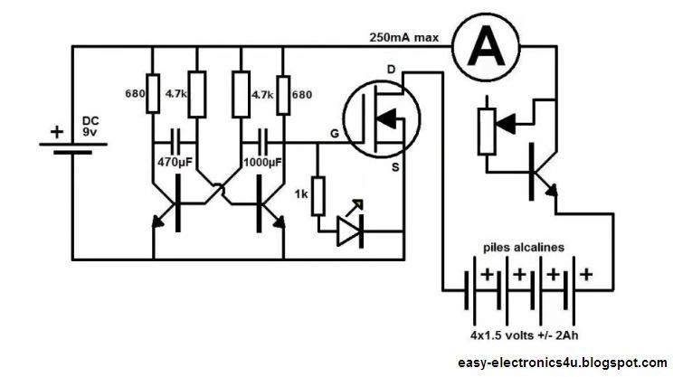

The circuit consists of a simple oscillator that charges the batteries for 2 seconds and stop for 4 seconds.

The oscillator drives the MOSFET that charges the batteries.

Choose any MOSFET type, and any small transistor, that handle the charging current. If you want to charge a lot of batteries, choose high current transistors.

Another transistor and a potentiometer control the charging current, to charge all types (AAA, AA or 9V).

**I recommend:**

* AA: 250mA max.
* AAA: 110mA max.
* 9V: 70mA max.

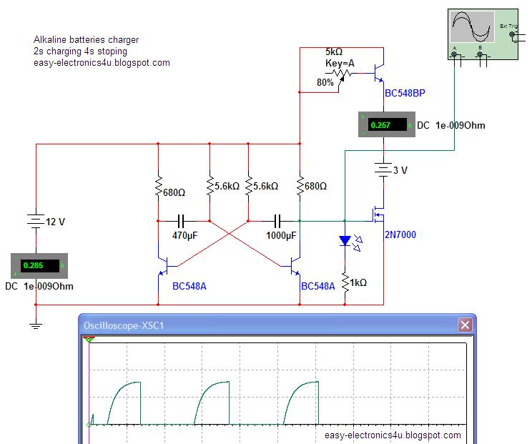

To recharge the batteries you must inject a voltage greater than the batteries voltage by X1.5.

This charger can charge as many batteries as you want! With 12 volts can be up to 6 (with more than 12 volts but in this case consider increasing the value of some resistors).

To make sure that your batteries are fully charged and that you are not damaging them, monitor their voltage. It should not exceed 110%. For example: a battery of 1.5V, maximum charge voltage is 1.65V.

(considering a regeneration of 80%), a 2Ah battery needs 20 hours for a complete recharge. Long? Not really if you're not pressed.

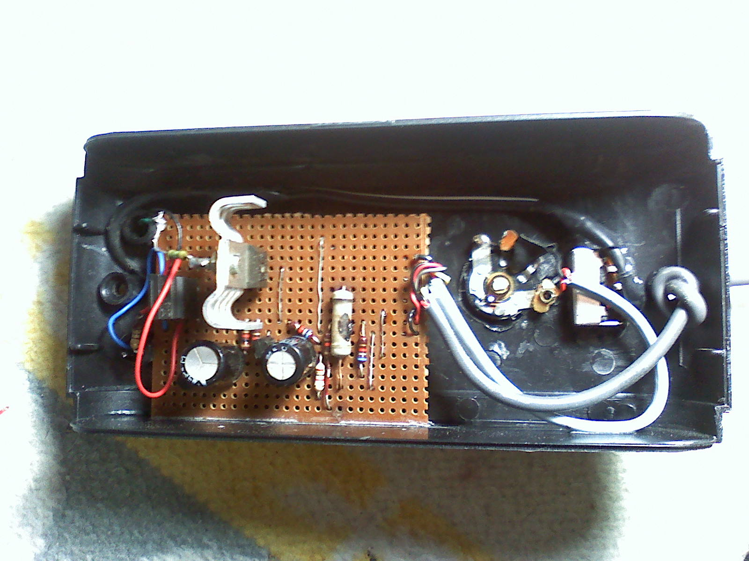

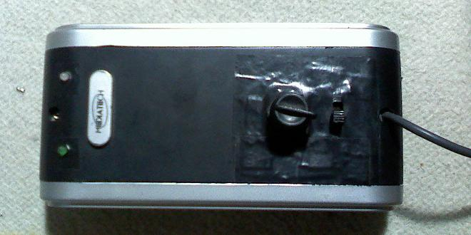

**Notes:**

Before charging the batteries try to select them: never take those that are not alkaline, leaking and rusty ones, which are of a brand that spells "cheap", that have "0.00 volts" or expired long ago. Remember that alkaline batteries can be recycled. No saline lithium or any non-alkaline battery as it won't work and will be dangerous.

Source video from YouTube (in French): https://www.youtube.com/watch?v=0AsIzmlBJiY