Pulse relay

*Domenico Di Mario*

https://digilander.libero.it/bubblegate/eindex.html

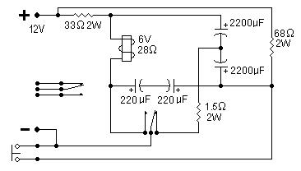

This circuit will convert a standard relay to a pulse relay; pressing the button will switch it on and pressing it again will switch it off. For this purpose you need a relay with 2 sets of contacts: one is used for the circuit and the other is available for an outside circuit. Sometimes it is difficult or impossible to find a stepping relay, normally used in electrical wiring, and this is a viable solution. The relay used in this circuit is a power relay with 10A contacts and a coil resistance of 28Ω. The circuit will draw no power when idle and it is possible to scale up the circuit to operate at a higher voltage. The relay must be always rated at half the supply voltage, in our case it is a 6V relay for a 12V supply. The resistor in series with the coil must have a similar resistance as the coil or slightly higher and the other resistor should be twice the coil resistance. All capacitors are 25V. The capacitor values depend on the coil resistance: the higher the resistance the lower the value. As it takes a certain time to charge the capacitors it is necessary to wait about 0.5-1 second between one operation of the push button and the next. An unregulated 12V power supply is adequate for this circuit.